# Week 1 : Create Web Page using Semantic Elements

<!DOCTYPE html>

<html>

<head>

<style>

h1 {

color: Black;

text-align: center;

}

p {

font-family: Lato; font-size: 20px;

}

aside { width: 30%;

padding-left: 15px; margin-left: 15px; float: right;

font-style: italic; background-color: lightblue;

}

.all-phones {

margin: 0; padding: 5px;

background-color: lightblue;

}

.all-phones > h1, .phone { margin: 10px;

padding: 5px;

}

.phone { background: white;

}

.phone2 {

background: lightblue;

}

</style>

</head>

<body>

<article class="all-phones">

<h1>TOP 3 Laptops in 2020</h1>

<article class="browser">

<h2>1. Dell Latitude E7270 </h2>

<p> Processor Name -

Core i5 6300HQ Core i5 Core i5 5300U Core i5<br> Screen Size -

12.5 in 14.1 in 14 in 14 in <br> Hard Disk Size -

Part inside laptop where data is stored. Offers high storage but slower than SSDs<br>

256 GB 256 GB 256 GB 500 GB<br>

Operating System -

Main software that runs the laptop. Windows, Linux & DOS are popular ones. DOS requires separate installation of operating system before using the laptop

Windows Windows 7 ProfessionalWindows Windows 10<br> Graphics coprocessor -

Graphics Processing Unit (GPU) is responsible for processing heavy graphical tasks. Quality of games & high resolution video depends on the type of GPU

Intel HD Intel HD Graphics 3000 Intel HD Graphics Intel HD Graphics</p>

<iframe width="560" height="315" src="https:/[/www.youtube.com/embed/2WU4fn82Q3Y](http://www.youtube.com/embed/2WU4fn82Q3Y)" frameborder="0" allow="accelerometer; autoplay; encrypted-media; gyroscope; picture-in-picture" allowfullscreen></iframe>

<aside>

<p>The video shows Dell Latitude E7270.</p>

</aside>

</article>

<article class="phone">

<h2>2. Lenovo IdeaPad 330 </h2>

<p>

Brand - Lenovo <br> Model - 81DE00WSIN<br>

Model Name - ideapad 330<br> Item Weight - 2.2 Kg

Product Dimensions - 37.8 x 26 x 2.3 cm Batteries: 1 A batteries required. (included) RAM Size - 4 GB<br>

Memory Storage Capacity 1 TB Ram Memory Installed Size 4 GB<br> Ram Memory Technology DDR4

Computer Memory Type DDR4 SDRAM Hard Drive Size 1024 GB

Hard Drive Interface - eSATA</p>

<iframe width="560" height="315" src="https://[www.youtube.com/embed/EYLSaNSAYow"](http://www.youtube.com/embed/EYLSaNSAYow) frameborder="0" allow="accelerometer; autoplay; encrypted-media; gyroscope; picture-in-picture" allowfullscreen></iframe>

<aside>

<p>The video shows Lenovo IdeaPad 330.</p>

</aside>

<br>

</article>

<article class="phone2">

<h2>3. Dell XPS 13 9360 </h2>

<p> Processor Name -Core i7 Core i7 Core i7 Core i7 8700T<br> Screen Size - 13.3 in 14 in 13.3 in 13.3 in<br>

Hard Disk Size -

Part inside laptop where data is stored. Offers high storage but slower than SSDs 512 GB 1 TB 512 GB 512 GB<br>

Operating System -

Main software that runs the laptop. Windows, Linux & DOS are popular ones. DOS requires separate installation of operating system before using the laptop

Windows 10 Home Windows 10 Home Windows 10 Windows 10 Home Single Language<br>

Graphics coprocessor -

Graphics Processing Unit (GPU) is responsible for processing heavy graphical tasks. Quality of games & high resolution video depends on the type of GPU

Intel UHD Graphics NVIDIA GeForce MX250 Intel Intel® UHD Graphics 620</p>

<iframe width="560" height="315" src="https:/[/www.youtube.com/embed/XiRYigT3mgc](http://www.youtube.com/embed/XiRYigT3mgc)" frameborder="0" allow="accelerometer; autoplay; encrypted-media; gyroscope; picture-in-picture" allowfullscreen></iframe>

<aside>

<p>The video shows Dell XPS 13 9360. </p>

</aside>

</article>

</article>

<section>

<h1>Dell Latitude E7270</h1>

<p>Dell Latitude E7270 (Full Touch, DDR4 RAM) is a 12.5'' Full Touch screen business Laptop which comes with Intel Core i7 6th Generation (6600U) processor clocked at 2.60 GHz with max Intel Turbo Boost Technology upto 3.4 GHz. It comes with 8 GB DDR4 RAM and 512 GB SSD and Full HD Display. It is a high end and compact laptop slim and easy to carry.</p>

<a href="https://[www.dell.com/](http://www.dell.com/)">Dell.com</a>

</section>

<section>

<h1>Lenovo IdeaPad 330</h1>

<p>The Lenovo IdeaPad 330 has a 15.6-inch display machine with 1366 x 768 pixels resolution, a DVD drive, and is priced affordably. The laptop is meant for daily users. It has an Intel Celeron N4100 CPU, 4GB of RAM, and a 500GB, 5,400-rpm hard drive.</p>

<a href="https://[www.lenovo.com/](http://www.lenovo.com/)">Lenovo.com</a>

</section>

<section>

<h1>Dell XPS 13 9360</h1>

<p>Dell XPS 13 Core i5 7th Gen - (8 GB/256 GB SSD/Windows 10 Home) 9360 Thin and Light Laptop (13.3 inch, Silver, 1.29 kg, With MS Office.</p>

<a href="https://[www.dell.com/](http://www.dell.com/)">Dell.com</a>

</section><br>

<nav>

<a href="https://[www.youtube.com/channel/UC7spQgQ9tFp0ifMCYmjmFMQ"](http://www.youtube.com/channel/UC7spQgQ9tFp0ifMCYmjmFMQ)>Laptop Reviews</a> <br>

<a href="https://[www.youtube.com/channel/UC4MTZ4CuurZUxTtcwR25OEQ"](http://www.youtube.com/channel/UC4MTZ4CuurZUxTtcwR25OEQ)>Tech Sphere</a>

</nav>

<footer>

<p>Author: Shubham Sharma</p>

<p><a href="<mailto:shubham066sharma@gmail.com>"[>shu](mailto:shubham066sharma@gmail.com)b[ham066sharma@gmail.com](mailto:shubham066sharma@gmail.com)</a></p><br>

</footer>

</body>

</html>

# Output

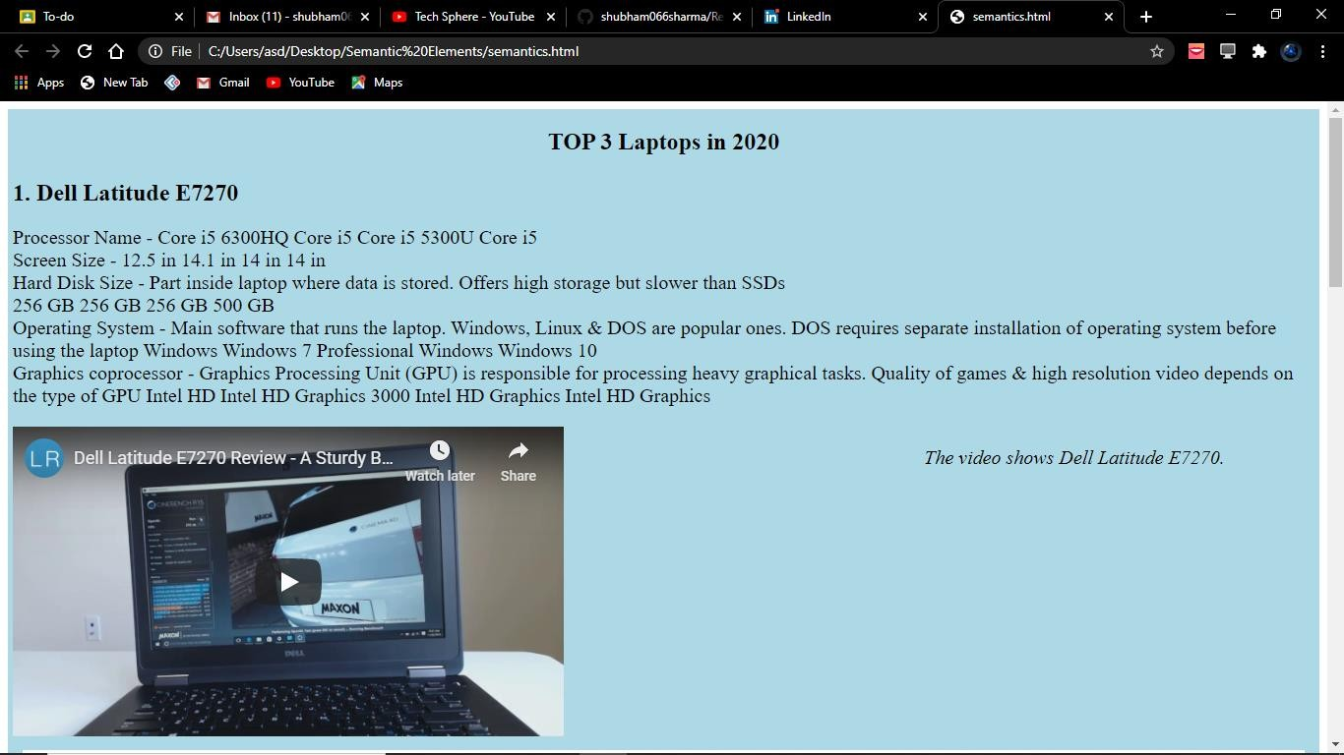

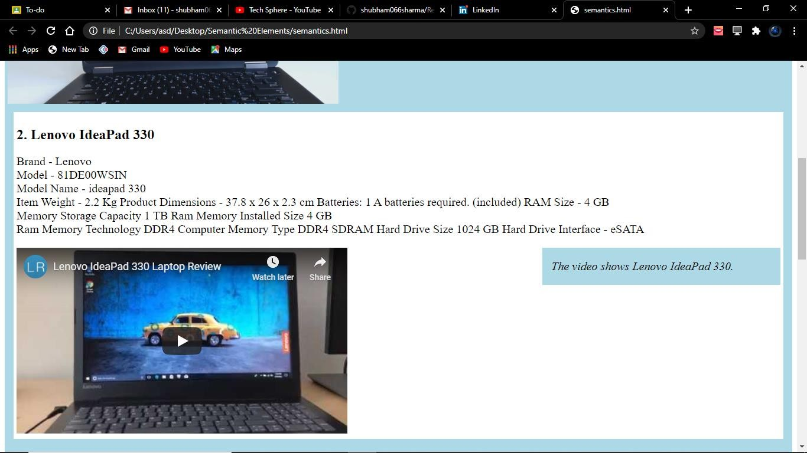

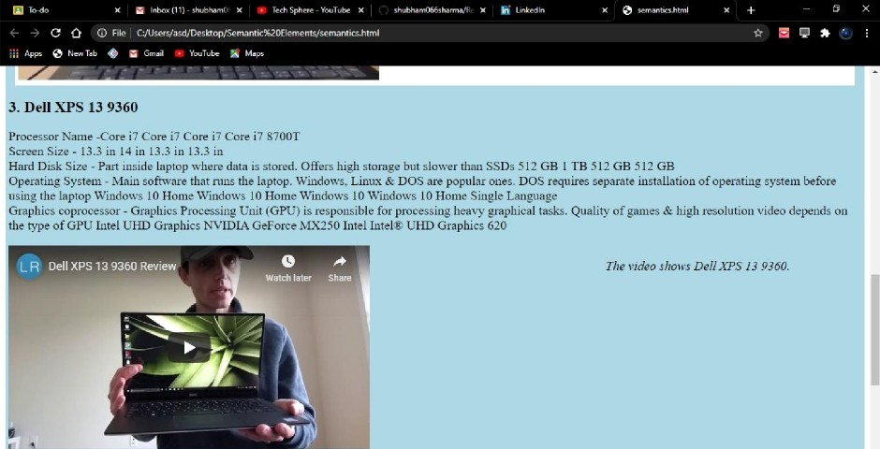

Dell Latitude E7270